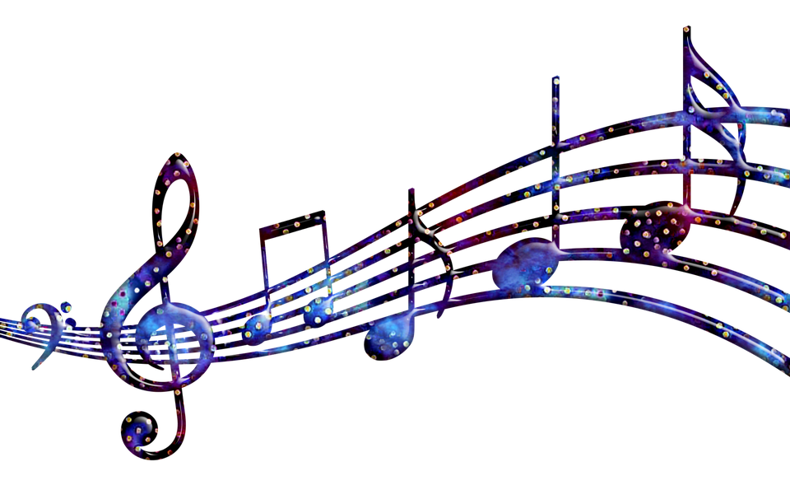 La Salle Academy Music Curriculum & Policies________________
Jr. High Grades: 6-8
Mrs. Maryanne DeMark

The Music Curriculum for the Junior High Grades at La Salle Academy is in compliance with state and national core curriculum standards, skills-based, progressive, and comprehensive in its scope. The curriculum was designed and written by all music teachers PreK through high school in the Diocese of Scranton. In Music class, students learn music by doing; that’s a lot of hands-on experience! We learn through various activities involving singing, playing instruments, music composition and improvisation, lyric writing, creative drama, play-acting, movement, dance, visual arts, and listening activities. Our goal is not to make each student a musician, but to offer each student exposure to the world of music and all it has to offer. This includes faith formation through the beautiful music of the Catholic Church and active participation in the Mass. This also includes music of different cultures and countries, music of different instruments, music of different rhythms, and music that your child might not otherwise ever hear! Research consistently shows that music as part of your child’s education helps your child excel in other academic areas. Music also allows for opportunities of social interaction and religious formation. Your child will definitely benefit from having music in the school curriculum!
Class time will include time to prepare for school Masses and Liturgies as well as concerts. Participation in a multi-grade concert for students in 1st through 8th grades is part of the Core Standards of Music Education and part of our curriculum here at La Salle Academy. Participation & preparation effort is graded by a rubric in Music. Students in Grades 4, 6, and 8 perform in our annual Christmas concert; students in 5th and 7th perform in our annual themed Spring concert.
The La Salle Academy Chorus program is open to students in Grades 4-8. The Chorus provides an opportunity for reading music and student performance. The Chorus rehearses every Tuesday after school till 3:30. They rehearse prior to every Liturgy during school time, which averages once a month. This program reinforces concepts learned in class and offers further musical instruction as well as an opportunity to form lasting friendships!

Grading at the Jr. High level is based on three components:

- Assessments of learning including tests, projects, and writing assignments
- Classroom assignments
- Participation and behavior (conduct) in all classroom activities, liturgies, and concerts (students are NOT graded on ability but on evidence of learning, effort, and participation).

Grading is as follows:

O Outstanding- Student consistently demonstrates above average understanding and application of material covered.
S Satisfactory - All work has been satisfactorily completed and student demonstrates adequate understanding of material covered.
I Improvement Needed - Student needs to improve in comprehension, conduct, and/or participation.
U Unsatisfactory - Student has failed the grading period.

Classroom Supplies: Students in grades 6-8 need a folder dedicated to Music Class, some loose leaf paper or a tablet FOR MUSIC, and something to write with for Music class.

(OVER)
SIXTH GRADE: Students will explore the “purpose” for music, and how music can be used as a tool of expression and relaxation. They will work with more complex rhythm patterns. Music elements to be studied will include volume (dynamics), speed (tempo), pitch, various rhythm patterns, scale patterns, various ways of harmonizing, and basic chord progression. They will study American music in several styles, and American composers. Students will be taught how to listen to music to appreciate a piece’s orchestration, form, and content. Music will be sung, played, or used as a listening activity. Students will study American composers and may do a research project on American composers and/or American music.

SEVENTH GRADE: Students will study music and rhythm forms from around the world, listening to and analyzing the music of composers from Medieval times to Modern times. Students will learn how culture and technology influence the orchestration and sounds of various pieces and our music today. Students will study scale patterns, basic chord structure, and work with more complicated melodies and harmonies. They will also study Twentieth Century (Modern) music and composers. Students will compose and perform various styles of music. Students will also research and write a music paper.

EIGHTH GRADE: Students will utilize all music knowledge gained since Kindergarten as they study the roots of today’s popular music. This will include the study of Blues, folk songs, American music, Jazz, Rock’n’Roll, Catholic hymns, and other popular forms of music. Students will be taught to analyze song form, rhythm quality, lyric content, basic chord structures, basic chord progression, and other aspects of music theory to gain an understanding of where today’s music got its start. A music research project that incorporates the use of technology will also be assigned. Students will study basic music theory, including rhythm, note reading, and meter. Students will be given the opportunity for hands-on experience with playing piano and guitar. They will demonstrate their knowledge of music in an original composition. Many opportunities for practicing writing skills in various styles are presented, including a research project on Blues composers and performers.

ALL JR. HIGH GRADES: Reading comprehension and writing skills are taught in all Jr. High Music classes. Writing skills are very important to academic success and are strongly stressed from Elementary grades through college. At La Salle Academy and in the Holy Cross System, we use the Collins Writing System to help students learn the foundations of great writing skills. As part of this, students will be assigned short essays and research projects to help develop these significant skills.

A Registration letter for Chorus will be sent home soon!

It is my honor and pleasure to instruct your child in Music Education. Thank you for choosing La Salle Academy and Catholic Education! ~ Mrs. DeMark, Music Teacher

